**Object Oriented Software Engineering**



**Name: Jaskirat Singh**

**Roll number: 05413202717**

**Section: CSE-1 (8th Semester)**

**Experiment No.: 1**

**Aim:** To perform feasibility study for Library Management System.

A Library Management System is a software built to handle the primary housekeeping functions of a library. Libraries rely on library management systems to manage asset collections as well as relationships with their members. Library management systems help libraries keep track of the books and their checkouts, as well as members’ subscriptions and profiles.

Library management systems also involve maintaining the database for entering new books and recording books that have been borrowed with their respective due dates.

**Objective**: Features already in Library Management System are as that any Library Member can search for the book by their title and their author. Each book consists of the unique number through which the books will be registered in the library and many more. Here what additionally we can add to the library management system is that particular books can be searched on the basis of their subject category or different genres. Additionally, the premium membership can be assigned to the members under which they can get some perks such as no fine after the due date for some days and they will get the book which they want all time. Feature of e-library can also be launched where members can get the authorised soft copies of books. Recommendation system can be built in it where the member will get suggestion for the books based on their past books reserved.

What are the problems with the existing system?

Problems with the existing system is that the current Library Management system is built on old methodologies and with old features. They must be rebuilt with new tech stack and the more interactive User Interface. Requesting feature is not there (for the members if they need book in urgency.

**Description:**

Any Library Management System will contain these features as ,any library member should be able to search books by their title, author, subject category as well by the publication date. Each book will have a unique identification number and other details including a rack number which will help to physically locate the book. There could be more than one copy of a book, and library members should be able to check-out and reserve any copy. We will call each copy of a book, a book item. The system should be able to retrieve information like who took a particular book or what are the books checked-out by a specific library member. There should be a maximum limit (5) on how many books a member can check-out. There should be a maximum limit (10) on how many days a member can keep a book. The system should be able to collect fines for books returned after the due date. Members should be able to reserve books that are not currently available. The system should be able to send notifications whenever the reserved books become available, as well as when the book is not returned within the due date. Each book and member card will have a unique barcode. The system will be able to read barcodes from books and members’ library cards. Additionally, feature of e-library must be introduced where members can get the soft copies of the books instead of visiting library. Premium membership must be introduced for the members where they will not be fined and will get more perks. Recommendation system must be built where it can suggest books according to past reservations.

**Estimated Requirements:**

* HARDWARE REQUIREMENTS:

1. A computer system with basic functionalities with minimum i3 core processor.
2. At least 4GB RAM
3. 122 Keys Keyboard

* SOFTWARE REQUIREMENTS:

1. Operating System (Windows, LINUX, MAC)
2. Web Browser (Firefox, Crome, Edge)

**Cost Estimation:**

|  |  |  |
| --- | --- | --- |
| S.NO | REQUIREMENTS | Cost |
| 1. | Hosting Service | Rs.65000(per year) |
| 2. | Domain Name | Rs.550(per year) |
|  | Total Cost: | Rs.65550 (per year) |

**Shortcomings:**

Hosting Service must be good otherwise server will get down and user will not be able to put the request on the system. It must be well distributed and does not dependent on single host. Authentication and authorization (basically security) must be good.

**Conclusion:**

Hence, with the existing features and some changes in this system can result it to be a good product.

**Experiment No.: 2**

**Aim**: To perform SRS (Software Review Specification) Library Management System.

# SOFTWARE REQUIREMENT SPECIFICATIONS (SRS)

1. **INTRODUCTION**
   1. **DOCUMENT PURPOSE**

The main objective of this document is to illustrate the requirements of the project Library Management system. The document gives the detailed description of the both

functional and non-functional requirements proposed by the client. The document is developed after a number of consultations with the client and considering the complete requirement

specifications of the given Project. The final product of the team will be meeting the requirements of this document.

# PRODUCT SCOPE

The product is designed for both the Users and Library Admin. It will be a helpful product in a very effective way as it will reduce the tiresome workload from both Users and Library Admin.

# REFERENCES AND ACKNOWLEDGMENTS

1. **OVERALL DESCRIPTION**
   1. **PRODUCT PERSPECTIVE**

The proposed Library Management System is an on-line Library Management System. This System will provide a search functionality to facilitate the search of resources. This search will be based on various categories viz. book name or the ISBN. Also Advanced Search feature is provided in order to search various categories simultaneously. Further the library staff

personnel can add/update/remove the resources and the resource users from the system.

# PRODUCT FUNCTIONALITY

Functionality of this system is:-

LIBRARIAN

* + - A librarian can issue a book to the student
    - Can view The different categories of books available in the Library
    - Can view the List of books available in each category
    - Can take the book returned from students
    - Add books and their information of the books to the database
    - Edit the information of the existing books.
    - Can check the report of the issued Books.
    - Can access all the accounts of the students.

USERS:

* + - Can view the different categories of books available in the Library
    - Can view the List of books available in each category

Can own an account in the library

* + - Can view the books issued to him
    - Can put a request for a new book
    - Can view the history of books issued to him previously
    - Can search for a particular book

# USERS CLASSES AND CHARACTERISTICS

There are various kinds of users for the product. Usually web products are visited by various users for different reasons.

The users include:

* + - Students who will be using the above features by accessing the Library online.
    - Librarian who will be acting as the controller and he will have all the privileges of an administrator.

# OPERATING ENVIRONMENT

This system will be operated on any computer with the following minimum specifications:-

1. Windows XP Service Pack-3 OR higher versions of windows.
2. Computer hardware should be build on INTEL chipset.
3. Minimum free RAM of 128 MB.
4. Internet connectivity required.

# DESIGN AND IMPLEMENTATION CONSTRAINTS

The design & implementation constraints are:-

The system database used should be an open-source technology.

1. The system should be implemented in Java Technology
2. The downtime of the system should be less than 10 min.
3. RAM usage should not exceed 1024MB
4. This system software size should not exceed 1GB.

# USER DOCUMENTATION

The user manual and help will be available online and can be accessed any time by any user. The manual will be updated on a regular basis so as to keep the contents up to date.

# ASSUMPTIONS AND DEPENDENCIES

It is assumed that the optimum internet connectivity speed will be more than 512Kbps.

If the bandwidth is less than this then the transaction completion will take more time to processed and to be complete.

# SPECIFIC REQUIREMENTS

* 1. **EXTERNAL INTERFACE REQUIREMENTS**
     1. **User Interface**

Various GUI elements like forms, images and standard buttons will be included in the User Interface.

# Software Interface

Software will work on Windows OS. The Database used will be an open-source database like MySql. And the system will run on Java Virtual Machine.

# Communication Interface

This system will require web browser, internet connection which supports HTTP

and server.

# FUNCTIONAL REQUIREMENTS

1. Issuing the books
2. Return the books
3. Search the stock of books
4. Record of books issued and returned
5. Calculate fine if required

# OTHER NON-FUNCTIONAL REQUIREMENTS

* 1. **PERFORMANCE REQUIREMENTS**

1. Login/Registration will not take more than 10 seconds.
2. Any financial transactions will not take more than 15 seconds.

# SAFETY AND SECURITY REQUIREMENTS

1. Database will be secured by authentication process.
2. Unauthorized access will be avoided and will be tracked.
3. Database backup will be maintained.

# SOFTWARE QUALITY ATTRIBUTES

1. System will be reliable.
2. System can be maintained easily.

**Experiment No.: 3**

**Aim**: To perform feasibility study for a Class Diagram for Library Management System.

**Theory**:

A Class Diagram in the Unified Modelling Language (UML) is a type of static structure diagram that describes the structure of a system by showing the system's classes, their attributes, operations (or methods), and the relationships among objects. The class diagram is the main building block of object-oriented modelling.

Class Diagram for Library Management System simply describes structure of Library Management System class, attributes, methods or operations, relationship among objects.

**Classes of Library Management System:**

* **Library Database Class:** It manages all operations of library database.
* **Librarian Class:** It manages all operations of Librarian.
* **User Class:** It manages all operations of user.
* **Books Class:** It manages all operations of books. It is basic building block of system.
* **Publisher Class:** It manages all operations of account.

**Attributes of Library Management System:**

* **Library Database Attributes:** ListBooks
* **Librarian Attributes:** Name, Id
* **User Attributes:** UserId, UserName, UserAddress, PhoneNo
* **Book Attributes:** BookId, BookName, BookAuthor, YearofPub, Price, Status
* **Publisher Attributes:** Id, Name, Adress, PhoneNo

**Methods of Library Management System :**

* **Library Database Methods:** AddBook(), RemoveBook(), ModifyBook(),
* **Librarian Methods: S**earchBook(), VerifyMember(), OrderBooks(), SellBooks()
* **User Methods:** ReturnBooks(), PayFine(), AddNewUser(), UpdateDetails(), DeleteUser(), BookPurchase()
* **Book Methods:** AddNewBooks(), DisplayBookDetails(), DeleteBooks(), InquireBook()
* **Publisher Methods:** AddPub(), ModifyPub(), DeletePub(), OrderStatus()

**Class Diagram of Library Management System**

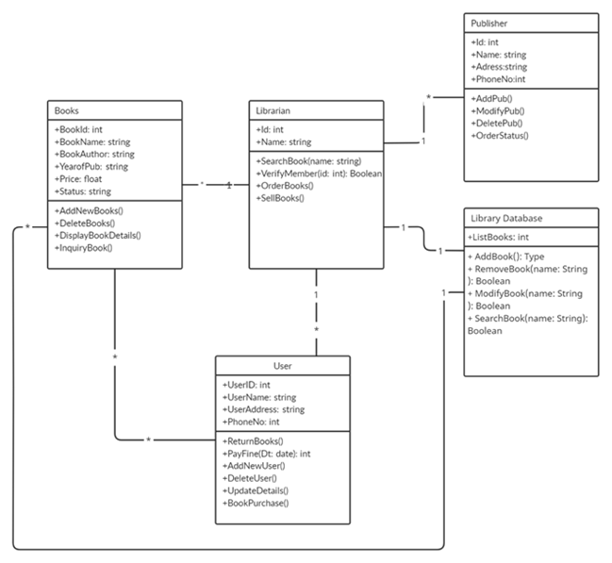

**Experiment No.: 4**

**Aim:**

To perform feasibility study for a Use Case Diagram for Library Management System.

**Theory:**

A use case diagram is a graphical depiction of a user's possible interactions with a system. A use case diagram shows various use cases and different types of users the system has and will often be accompanied by other types of diagrams as well.

The use cases are represented by either circles or ellipses. The actors are often shown as stick figures.

**Use Case Diagram for Library Management System:**

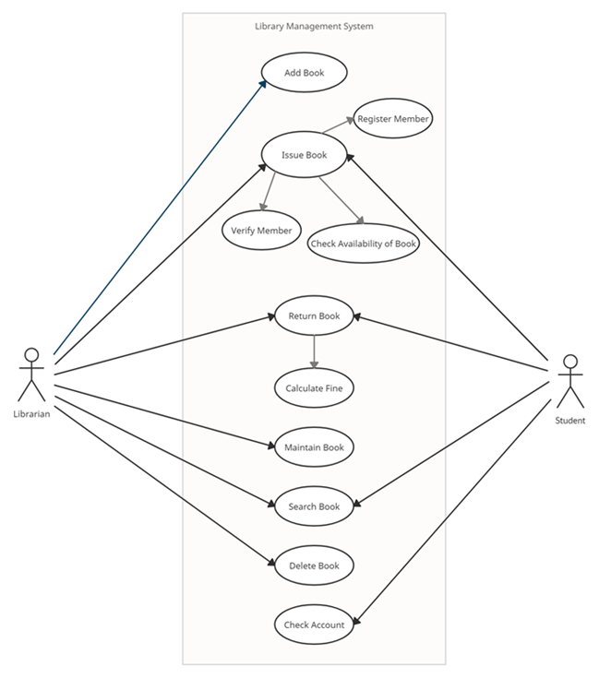

**Experiment No.: 5**

**Aim:**

To perform feasibility study for Activity Diagram for Library Management System.

**Theory:**

An Activity Diagram visually presents a series of actions or flow of control in a system similar to a [flowchart](https://www.smartdraw.com/flowchart/) or a [data flow diagram](https://www.smartdraw.com/data-flow-diagram/). Activity diagrams are often used in business process modelling.

They can also describe the steps in a [use case diagram](https://www.smartdraw.com/use-case-diagram/). Activities modelled can be sequential and concurrent. In both cases an activity diagram will have a beginning (an initial state) and an end (a final state).

Library Management System Class Diagram describes the structure of a Library Management System classes, their attributes, operations (or methods), and the relationships among objects. The main classes of the Library Management System are Student, Books, Issues, Librarian, Member, Address.

**Activity Diagram for Library Management System:**

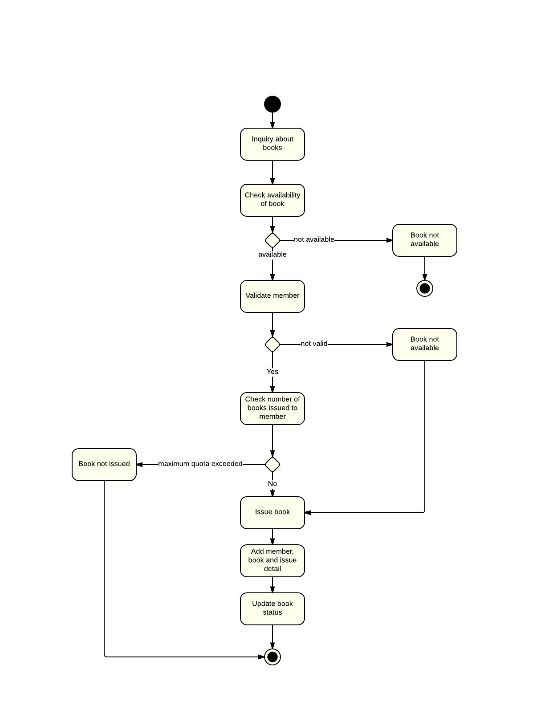

**Experiment No.: 6**

**Aim:**

To perform feasibility study for State Chart Diagram for Library Management System.

**Theory:**

Statechart diagram is one of the five UML diagrams used to model the dynamic nature of a system. They define different states of an object during its lifetime and these states are changed by events. Statechart diagrams are useful to model the reactive systems. Reactive systems can be defined as a system that responds to external or internal events.

Statechart diagram describes the flow of control from one state to another state. States are defined as a condition in which an object exists and it changes when some event is triggered. The most important purpose of Statechart diagram is to model lifetime of an object from creation to termination.

Statechart diagrams are also used for forward and reverse engineering of a system. However, the main purpose is to model the reactive system.

Following are the main purposes of using Statechart diagrams −

* To model the dynamic aspect of a system.
* To model the life time of a reactive system.
* To describe different states of an object during its life time.
* Define a state machine to model the states of an object.

**State Chart Diagram for Library Management System:**

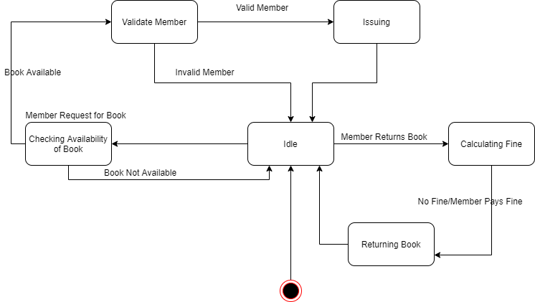

**Experiment No.: 7**

**Aim:**

To perform feasibility study for Sequence Diagram for Library Management System.

**Theory:**

A sequence diagram is a type of interaction diagram because it describes how—and in what order—a group of objects works together. ... Sequence diagrams are sometimes known as event diagrams or event scenarios. Note that there are two types of sequence diagrams: UML diagrams and code-based diagrams.

**Sequence Diagram for Library Management System:**

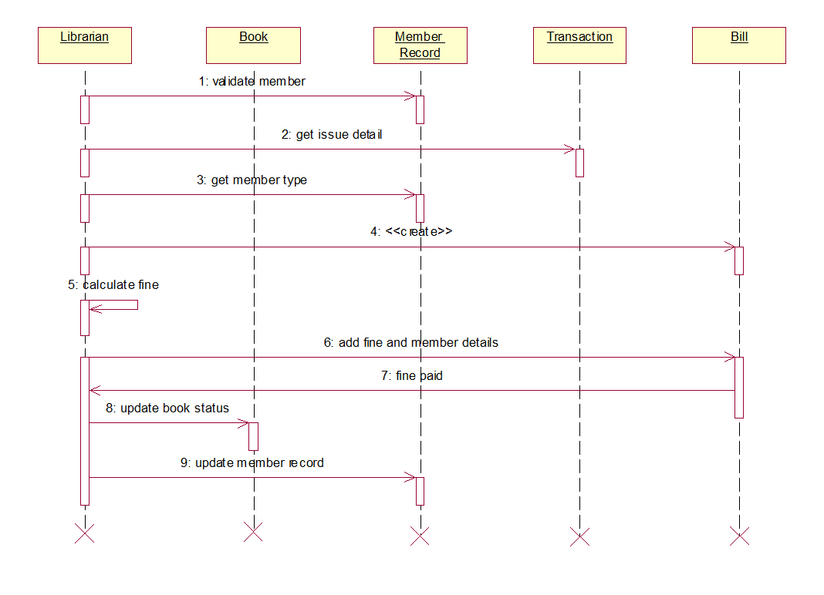

**Experiment No.: 8**

**Aim:**

To perform feasibility study for Collaboration Diagram for Library Management System.

**Theory:**

A collaboration diagram, also known as a communication diagram, is an illustration of the relationships and interactions among software objects in the Unified Modeling Language (UML). These diagrams can be used to portray the dynamic behavior of a particular use case and define the role of each object.

**Collaboration Diagram for Library Management System:**

